Object Detection Evaluation Short Discussion

1. Notebook Results and their interpretation
The evaluation produced the following metrics: 8 ground truth objects, 12 predicted boxes, 10 detections after NMS, 3 True Positives, 7 False Positives, 5 False Negatives, 30% Precision, 37.5% Recall, and 47.92% AP@0.5.
The low precision and recall values indicate that the model struggles with both localization accuracy and detection completeness. The maximum IoU of 0.7052 and mean IoU of 0.091 reveal poor overlap between predictions and ground truths, which explains the high number of false positives and false negatives. NMS reduced detections from 12 to 10, removing only 2 redundant boxes without impacting the true positive count.

2. The Effect of the IoU Threshold on Precision
Increasing the IoU threshold from 0.5 to 0.75 makes the matching criterion stricter, causing detections with moderate overlap to be reclassified from True Positives to False Positives. This reduces the TP count while increasing the FP count, which consequently causes precision to decrease. This demonstrates the inherent trade-off between localization precision and detection recall in object detection systems.

3. How NMS Reduces False Positives
Non-Maximum Suppression reduces false positives by eliminating duplicate detections of the same object. The algorithm selects the box with the highest confidence and suppresses all other boxes that have an IoU above the threshold of 0.5, ensuring each object contributes only one detection. Without NMS, duplicate detections could be counted as multiple True Positives or False Positives, artificially inflating performance metrics.

4. The Impact of Anchor Boxes on Evaluation
Anchor boxes are predefined bounding box shapes used in modern detectors such as Faster R-CNN and YOLO, and they influence the detection phase rather than the evaluation pipeline itself. If the ground truth boxes do not correspond well to the anchor shapes, the model may produce poorer quality predictions with lower IoU values. Poorly designed anchor boxes manifest as lower precision, recall, and AP scores in the final evaluation metrics.

5. Comparison Between COCO mAP and mAP@0.5
COCO mAP is stricter than mAP@0.5 because it averages Average Precision across ten different IoU thresholds ranging from 0.5 to 0.95 in increments of 0.05. A detector that performs well only at IoU 0.5 but poorly at higher thresholds will score significantly lower in COCO mAP. This comprehensive evaluation favors detectors that produce accurate bounding boxes consistently across all localization precision levels.

6. Conclusion
The model detects only 3 out of 8 objects correctly, produces 7 false positives, and achieves a moderate AP of 47.92%, indicating room for improvement. The model requires better localization precision and fewer false positive detections. The evaluation pipeline successfully computed all required metrics and provided meaningful insights for guiding future model improvements.

7. Precision-Recall Curve
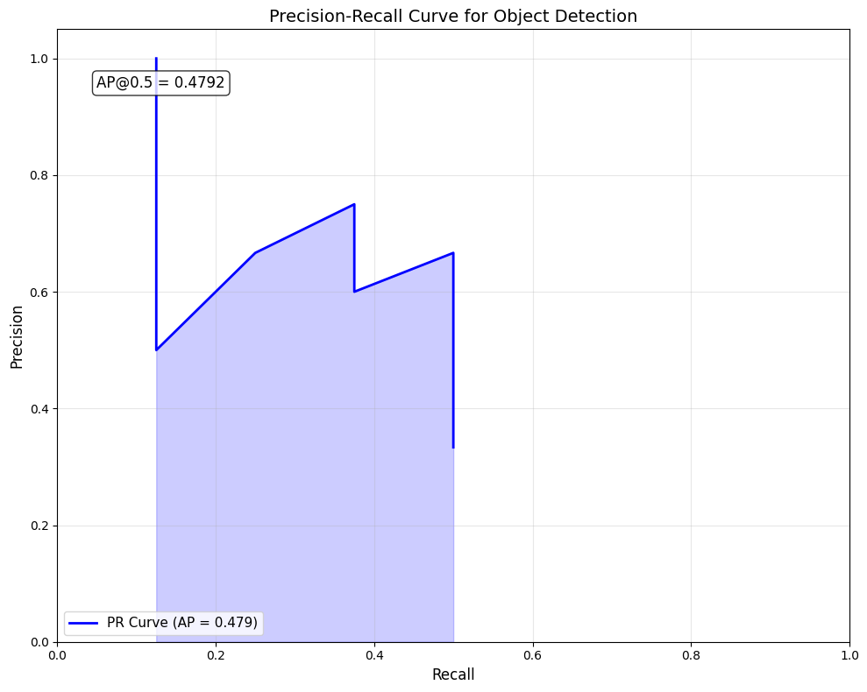

The PR curve shows the trade-off between precision and recall as the confidence threshold varies. The area under this curve (AP@0.5 = 0.4792) represents the model's overall detection performance at IoU threshold 0.5.

